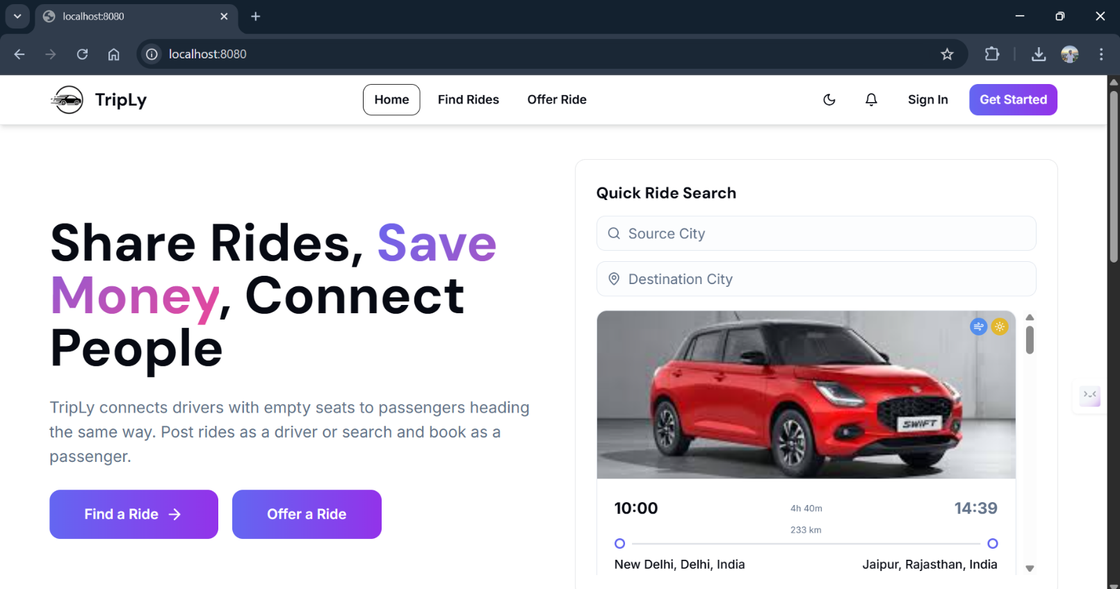

3.1 Landing Page

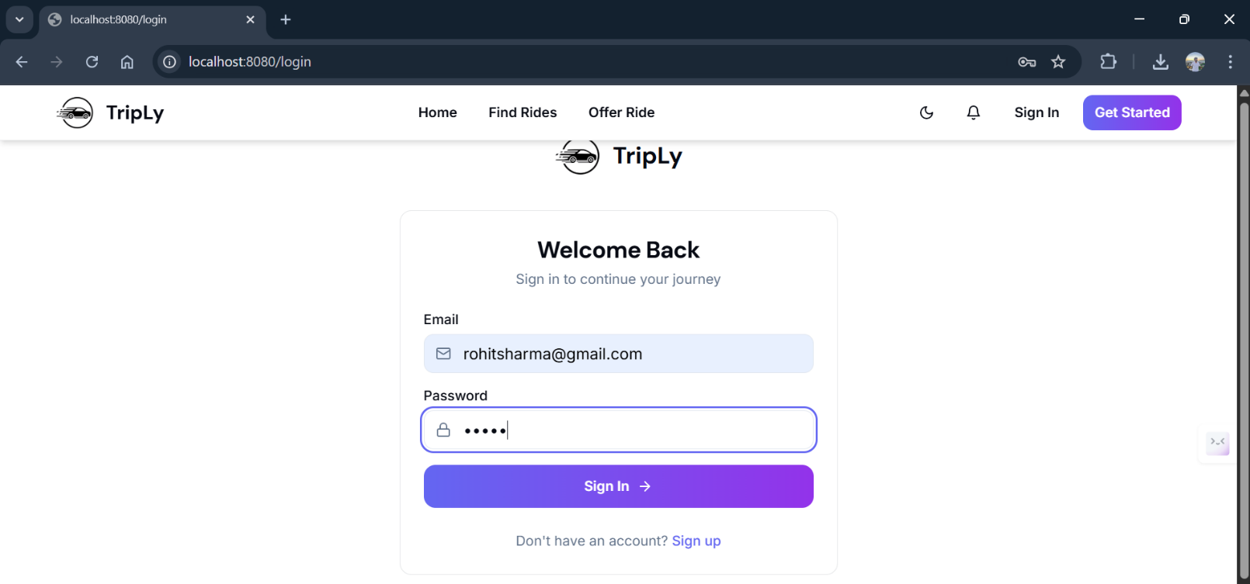

3.2 : Passenger Login credentials

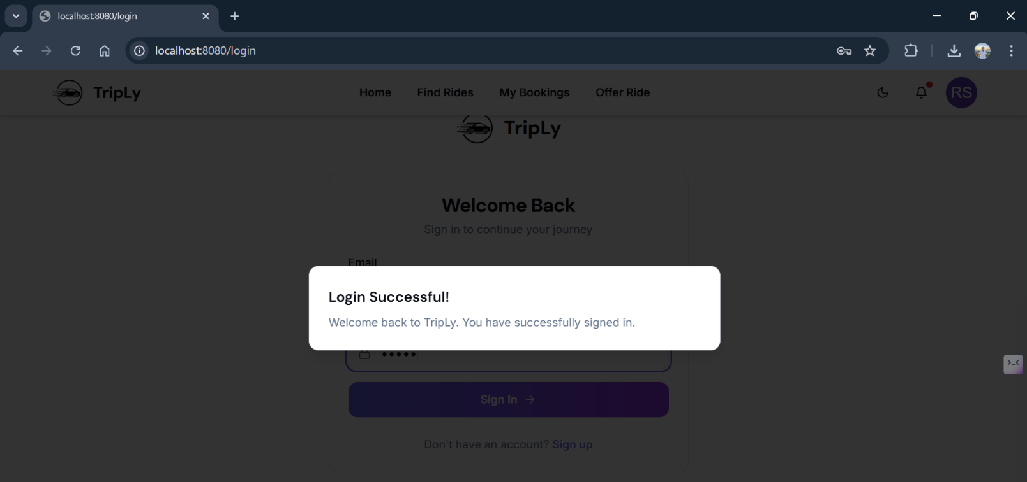

3.3 : Passenger Login Successful

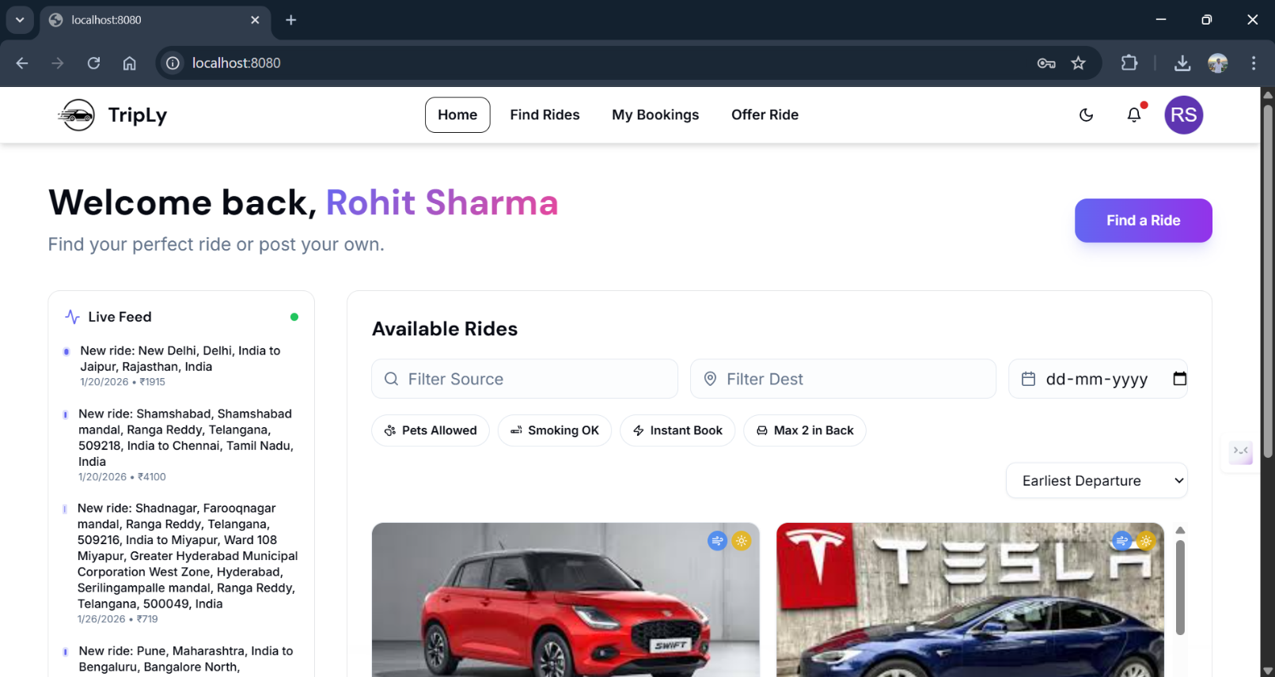

3.4 : Passenger Home Page

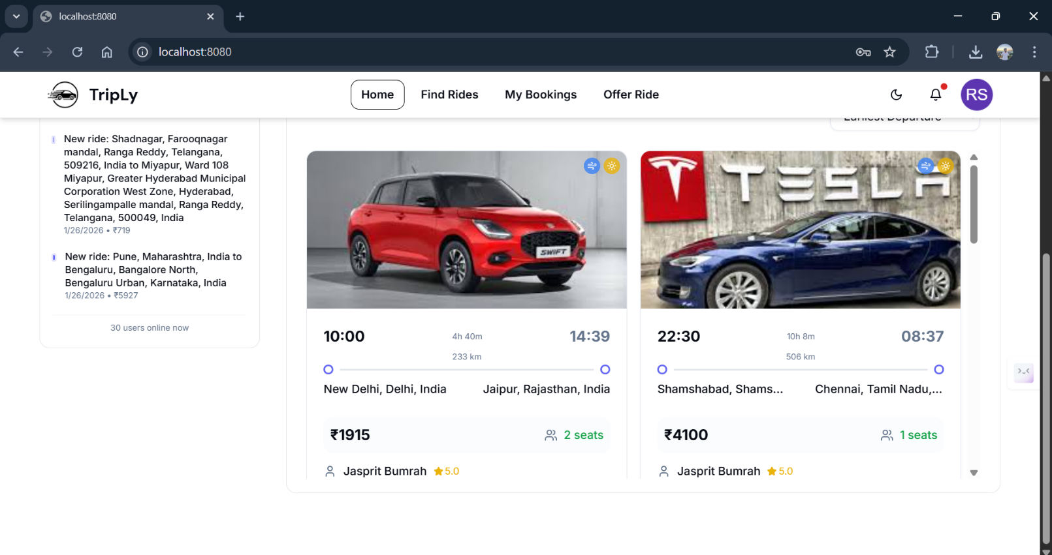

3.5 : Passenger Home Page

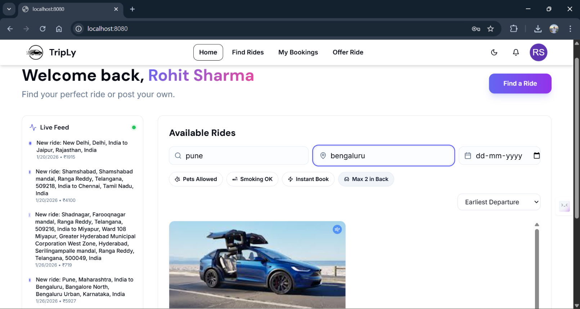

3.6 : Ride Search

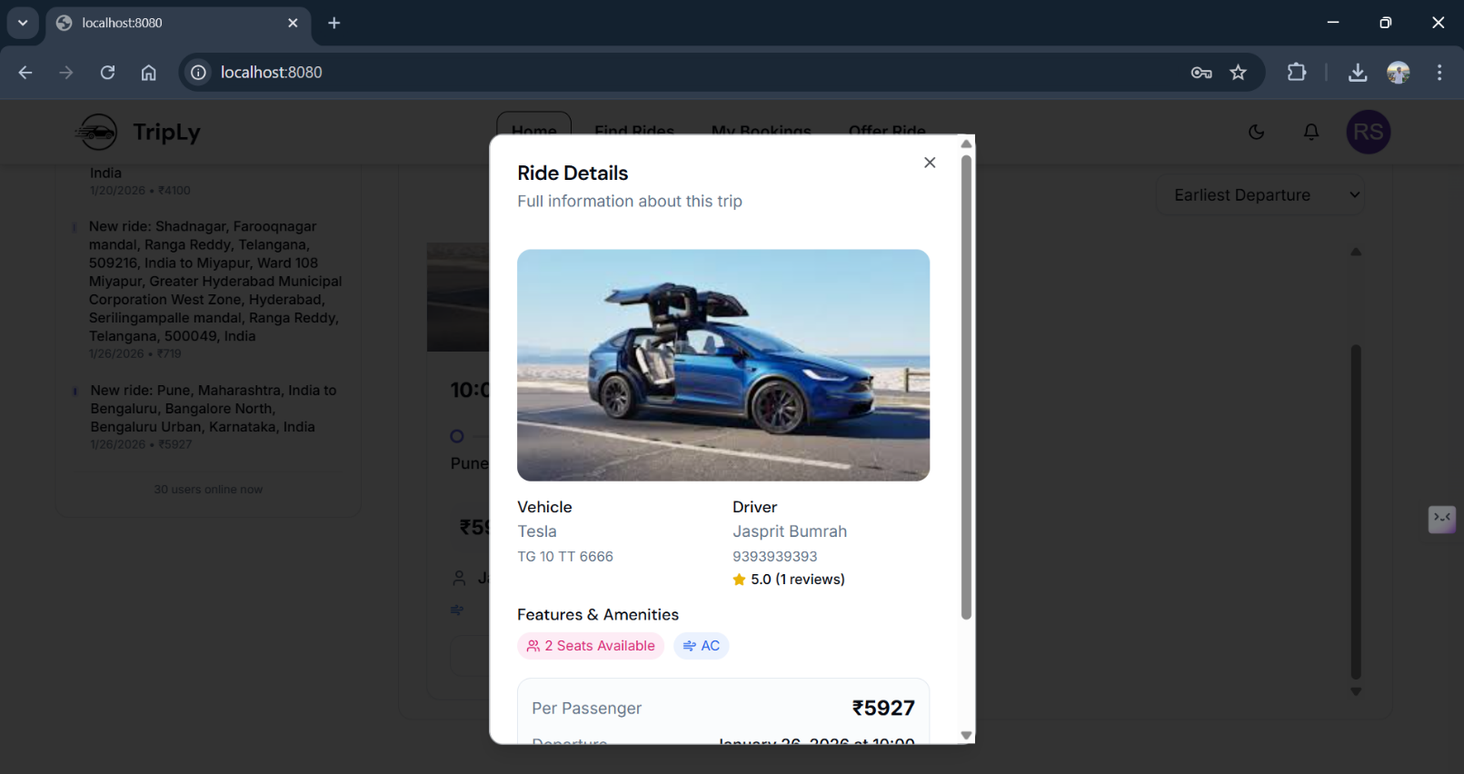

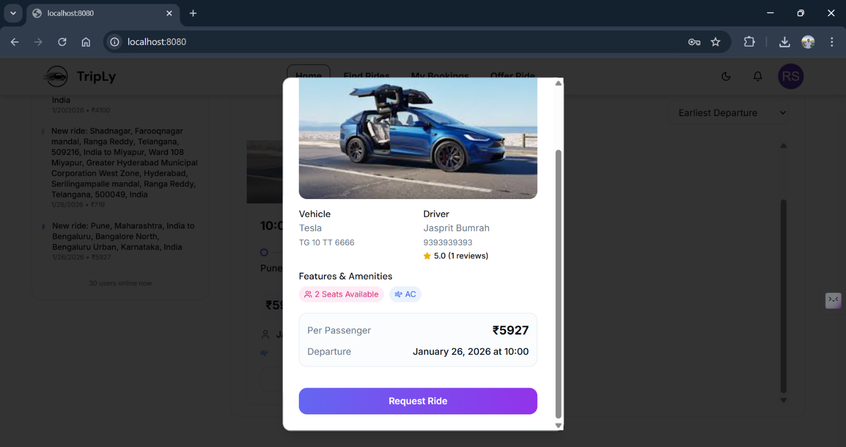

3.7 : Ride Details

3.8 : Request Ride

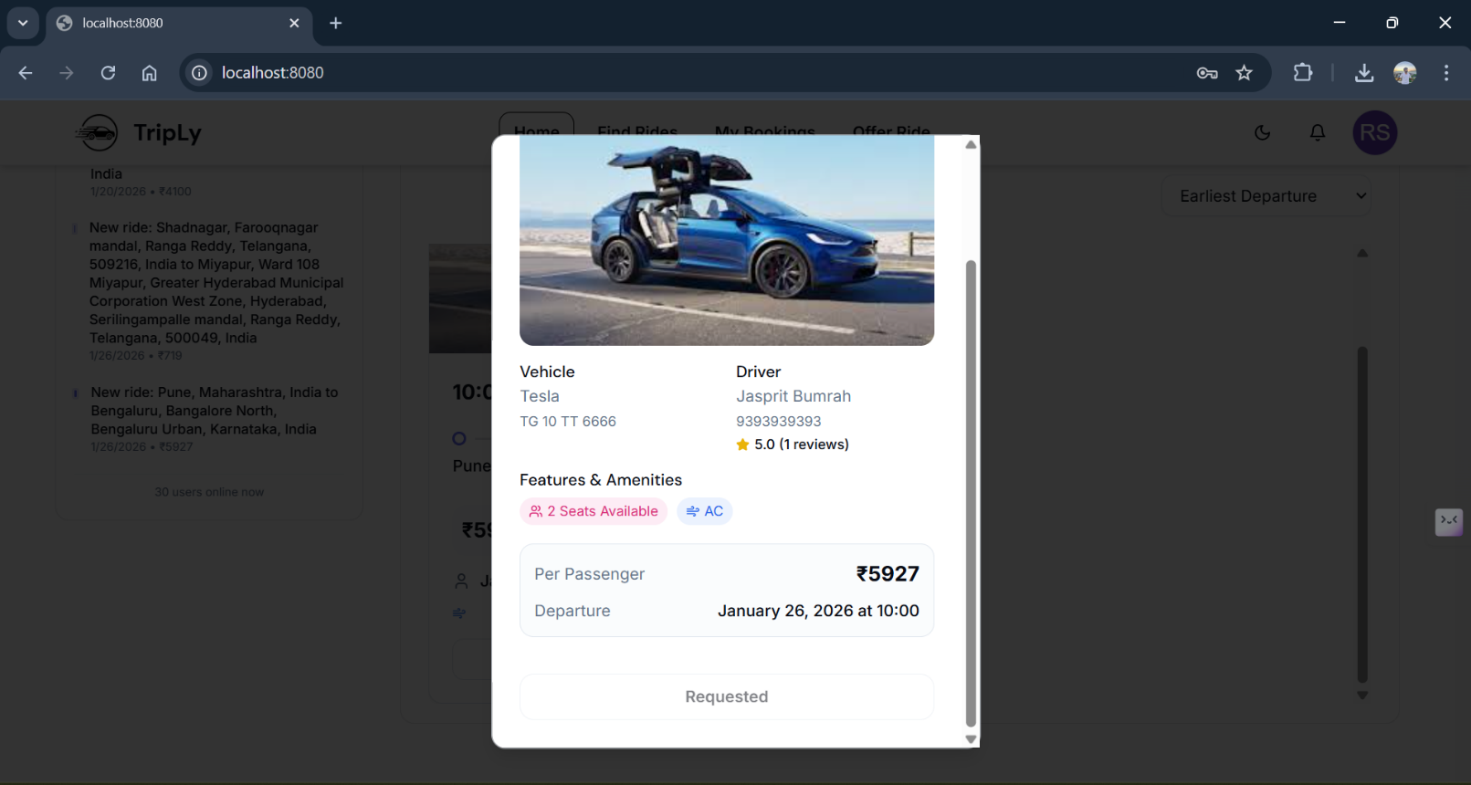

3.9 Ride Requested

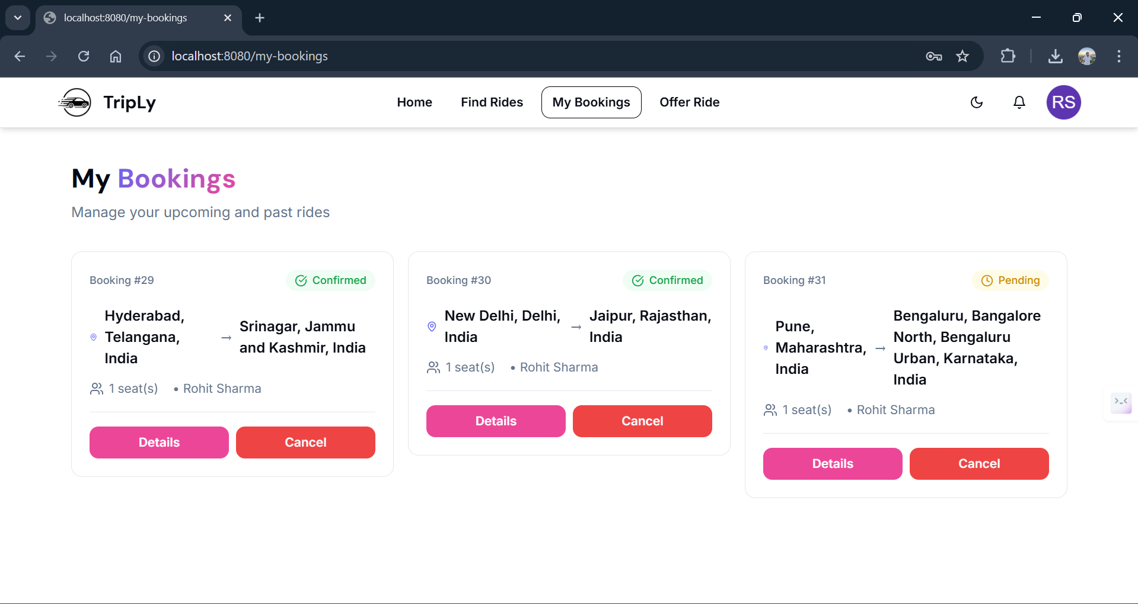

3.10 : Ride Status “Pending”

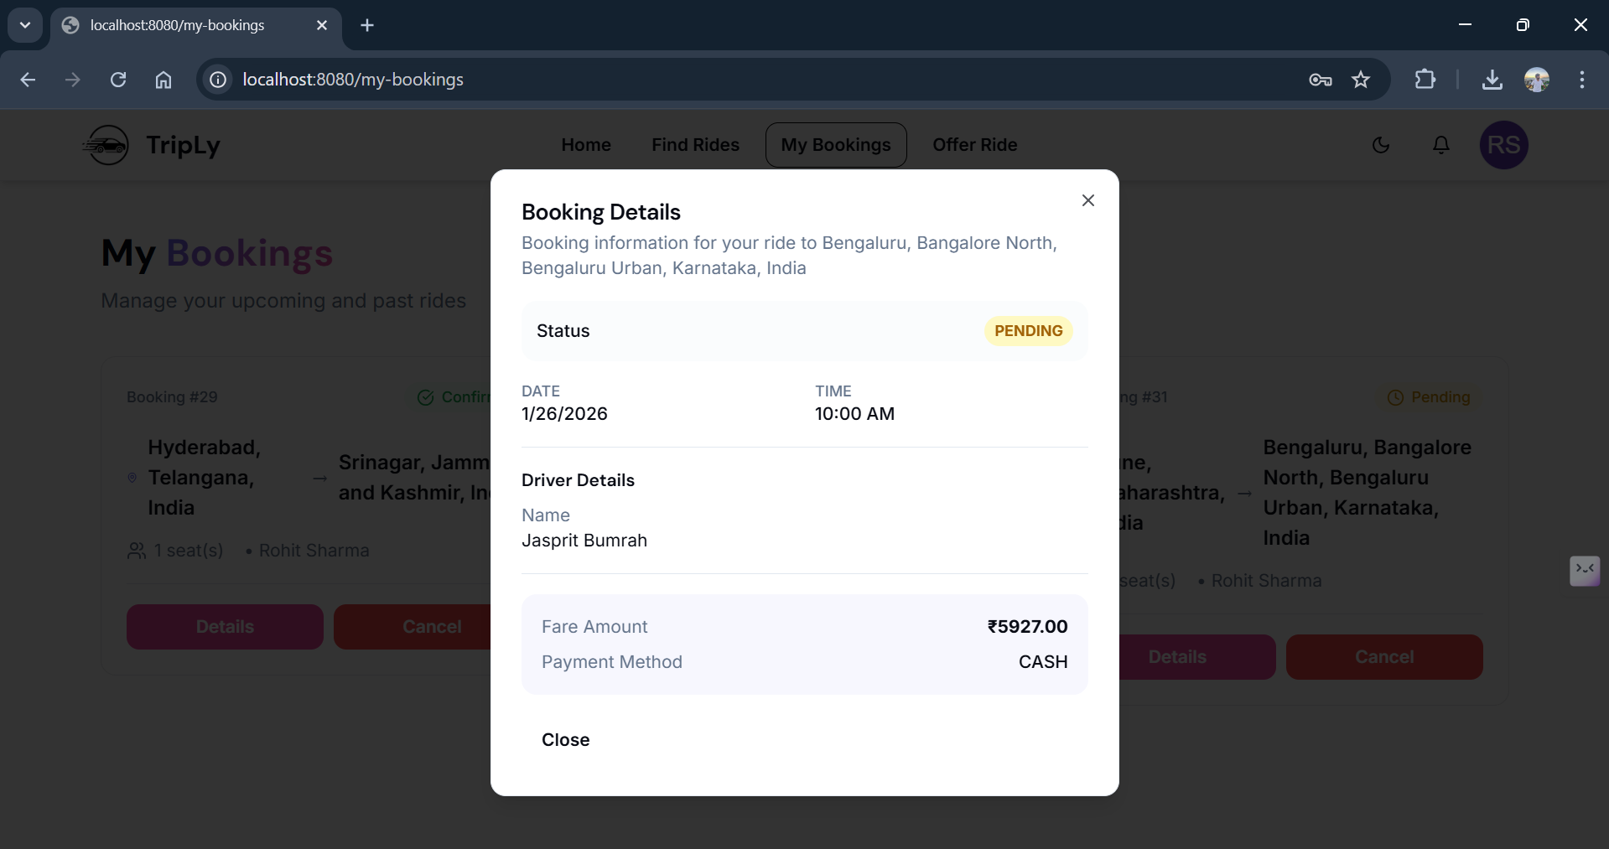

3.11 : Ride Request Details

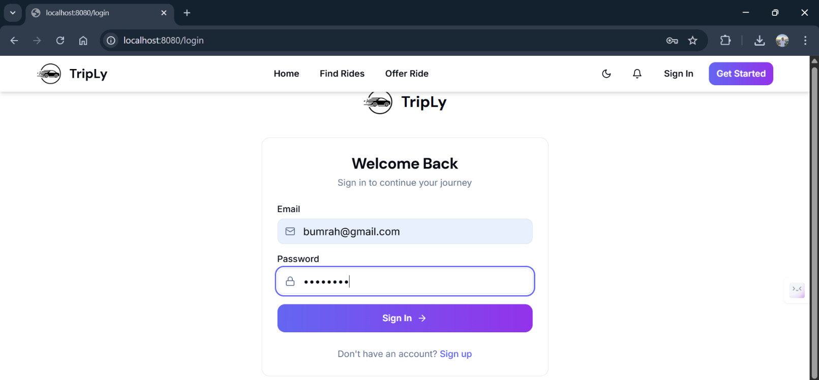

3.12 : Driver Login credentials

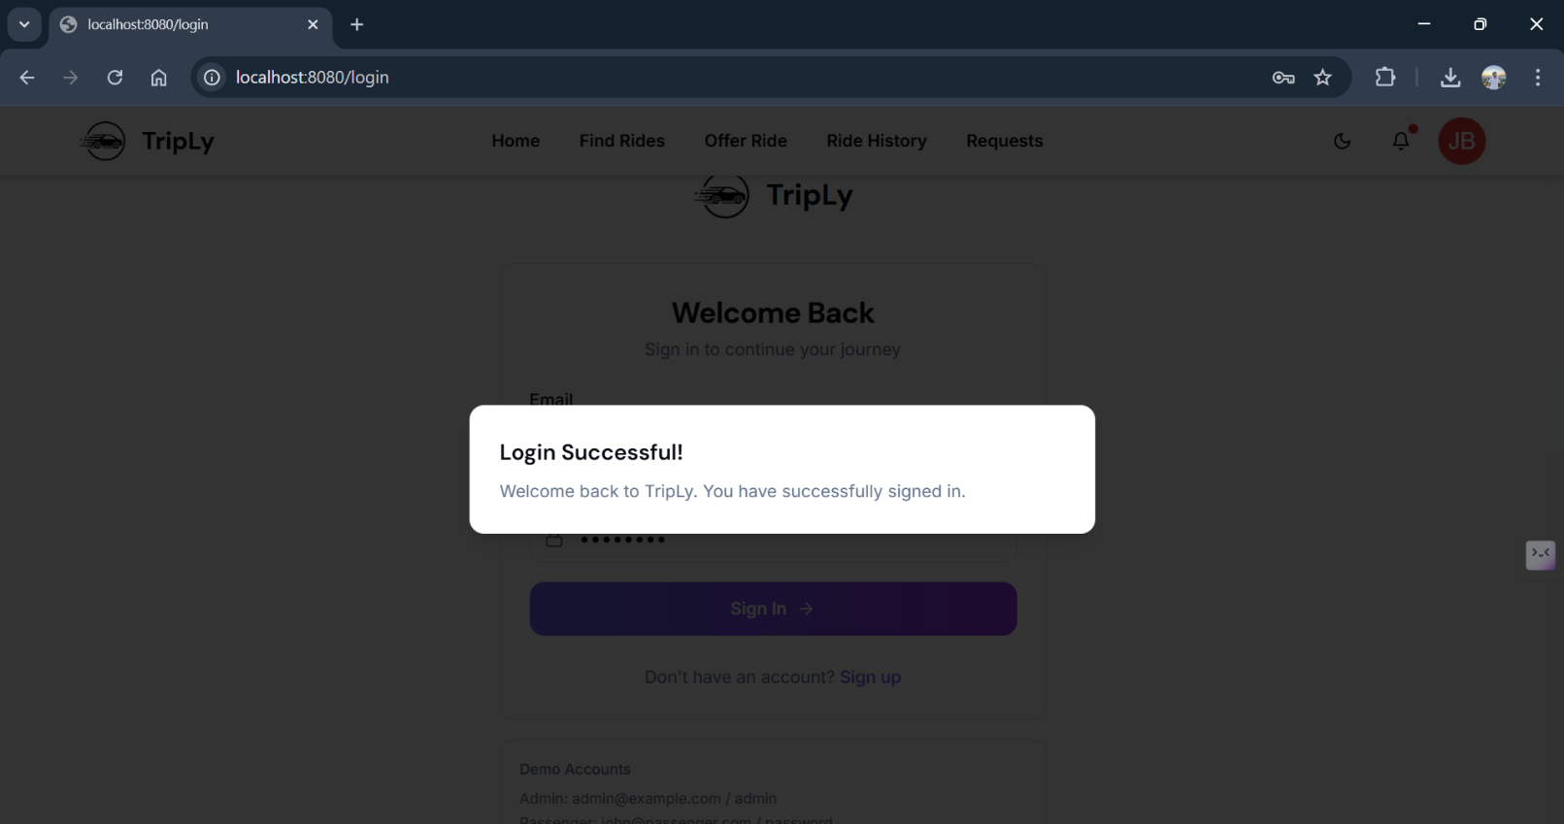

3.13 : Driver Login successful

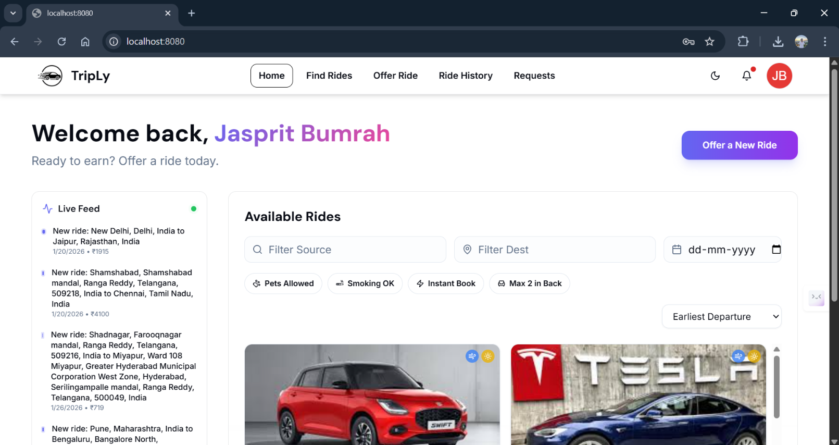

3.14 : Driver Home Page

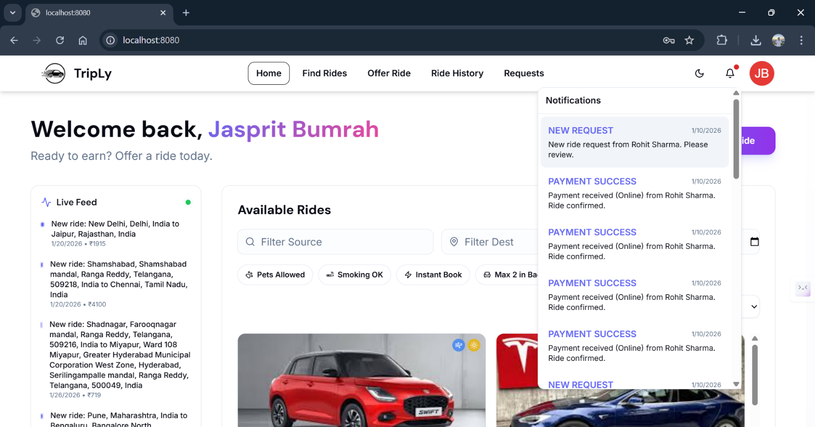

3.15 : Driver Notifications

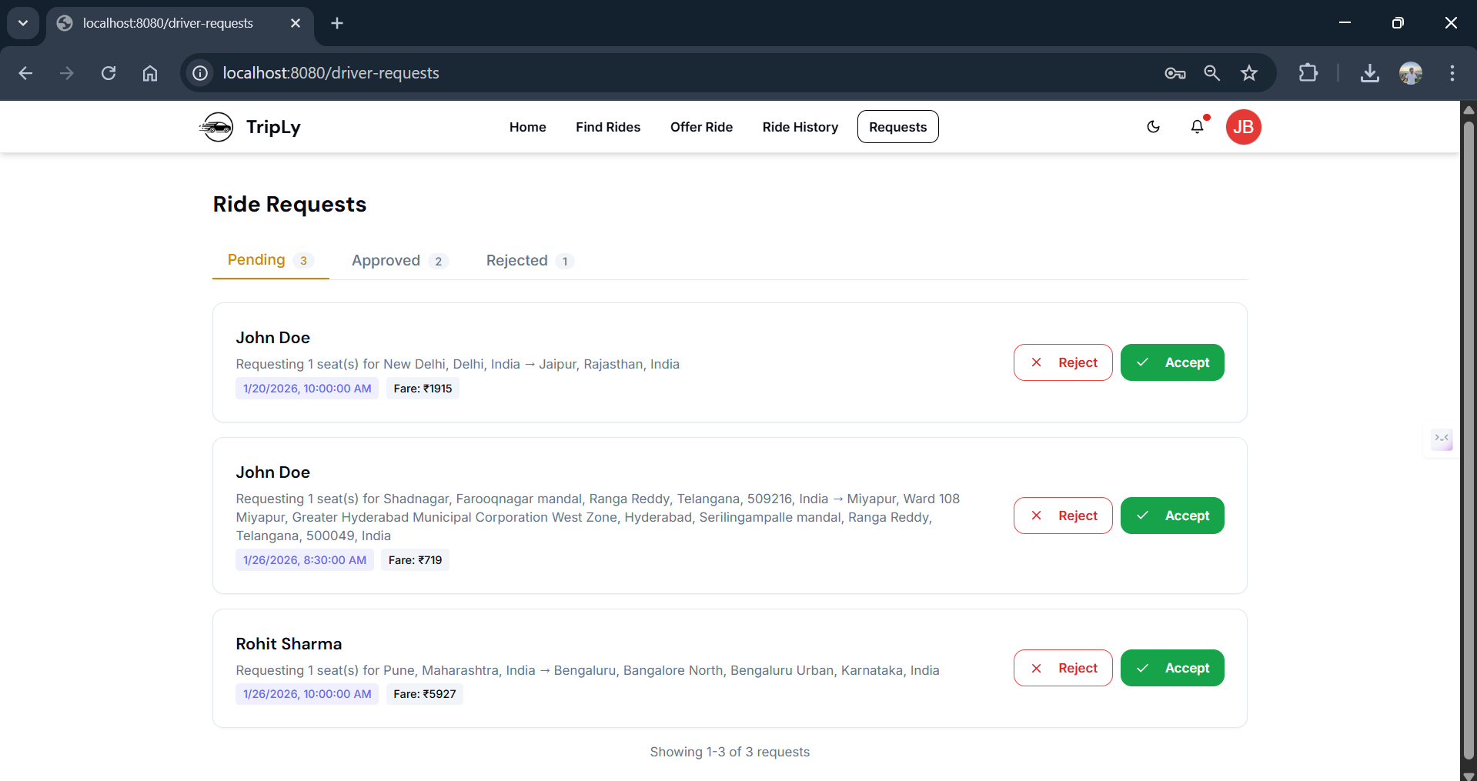

3.16 : Pending Ride Requests to the Driver

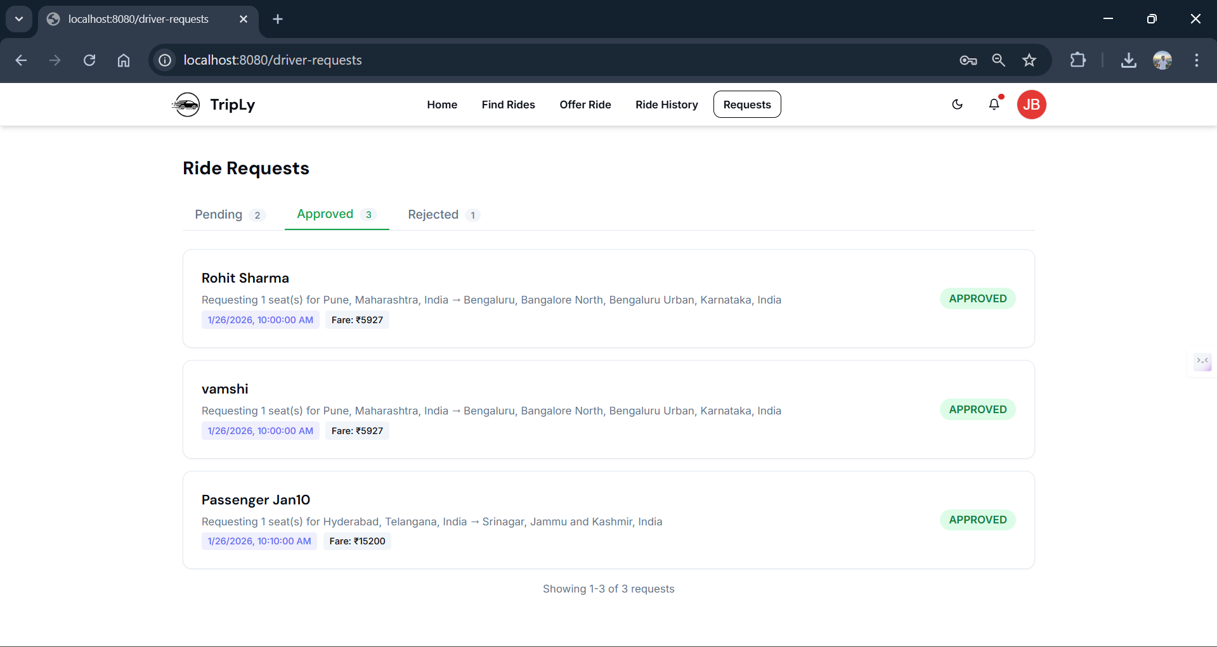

3.17 : Approved Ride Requests by the Driver

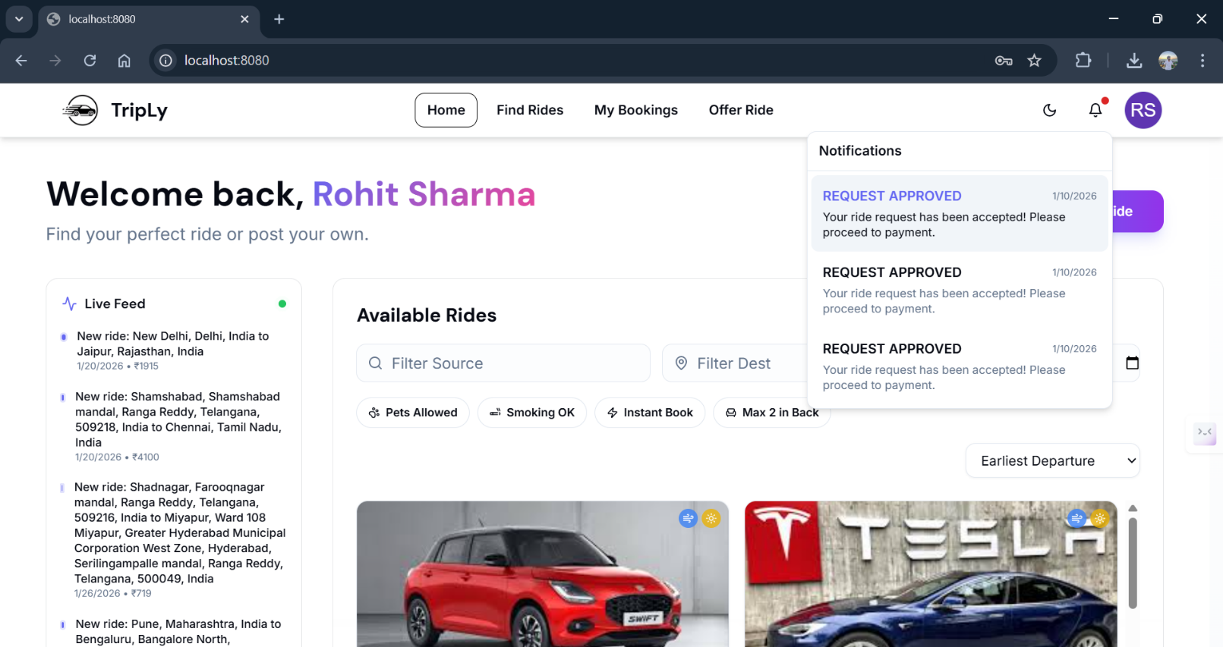

3.18 : Passenger Notifications of Ride Approval

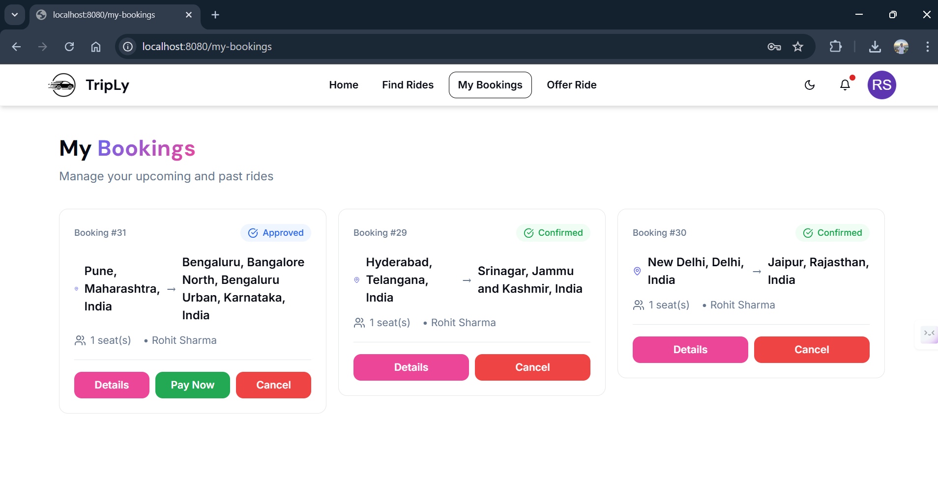

3.19 : Ride Status “Pay Now”

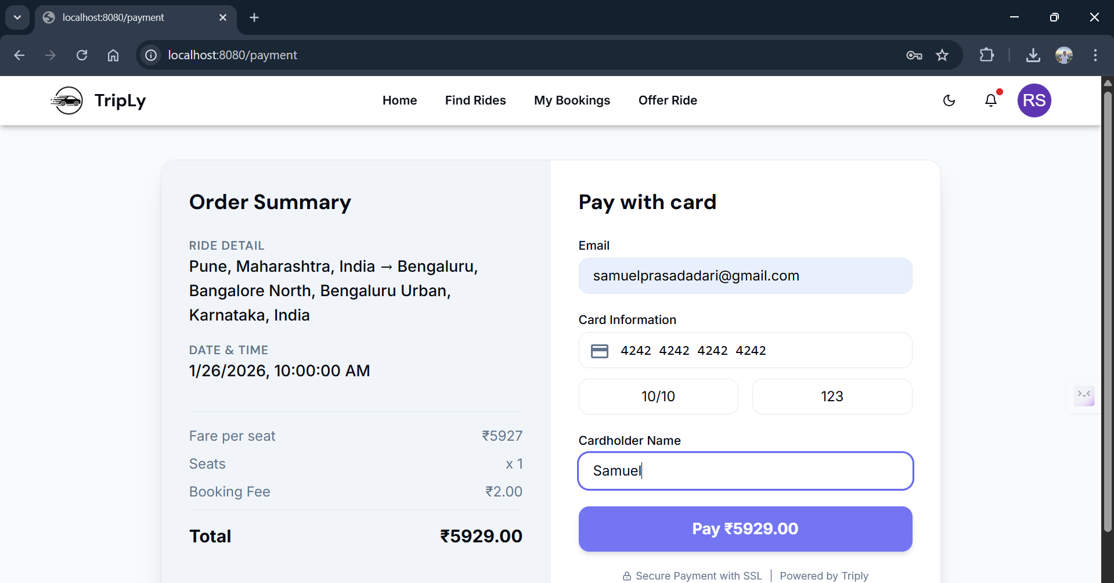

3.20 : Payment for the approved Ride

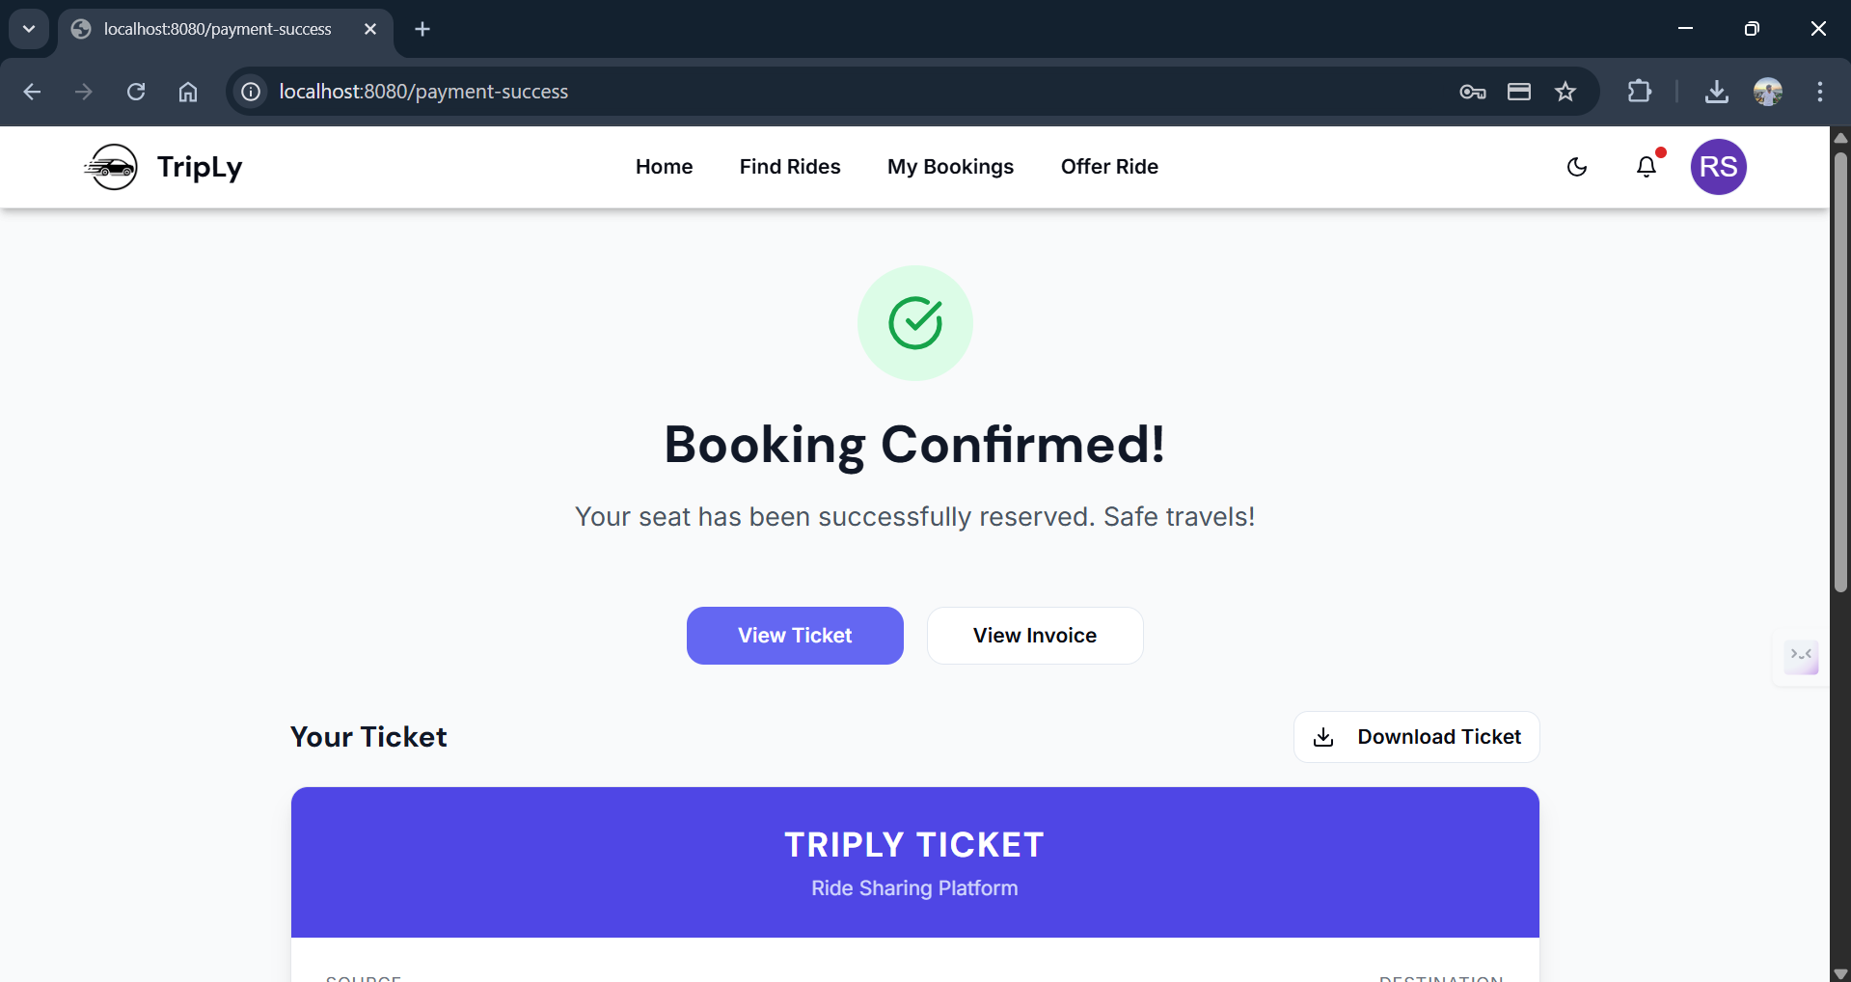

3.21 : Payment and Booking Successful

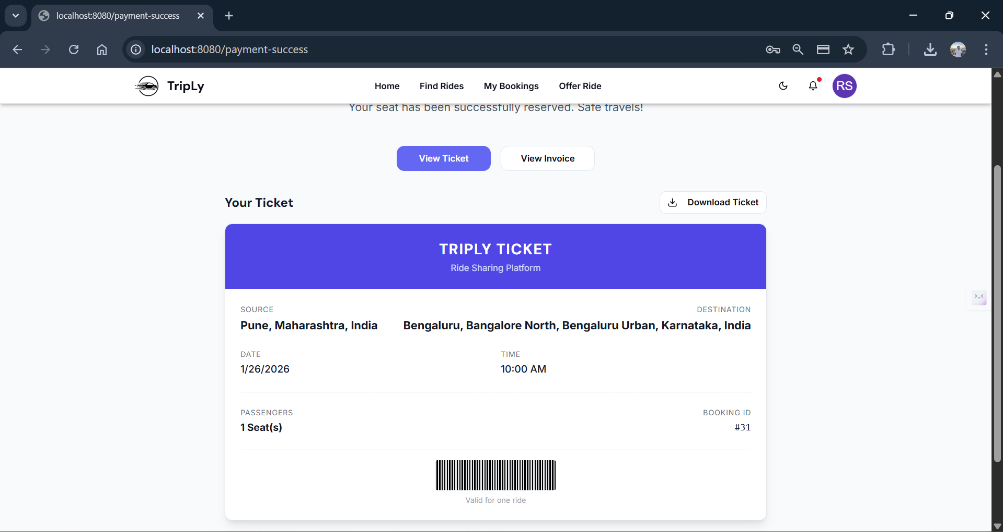

3.22 : Ticket/Booking confirmed

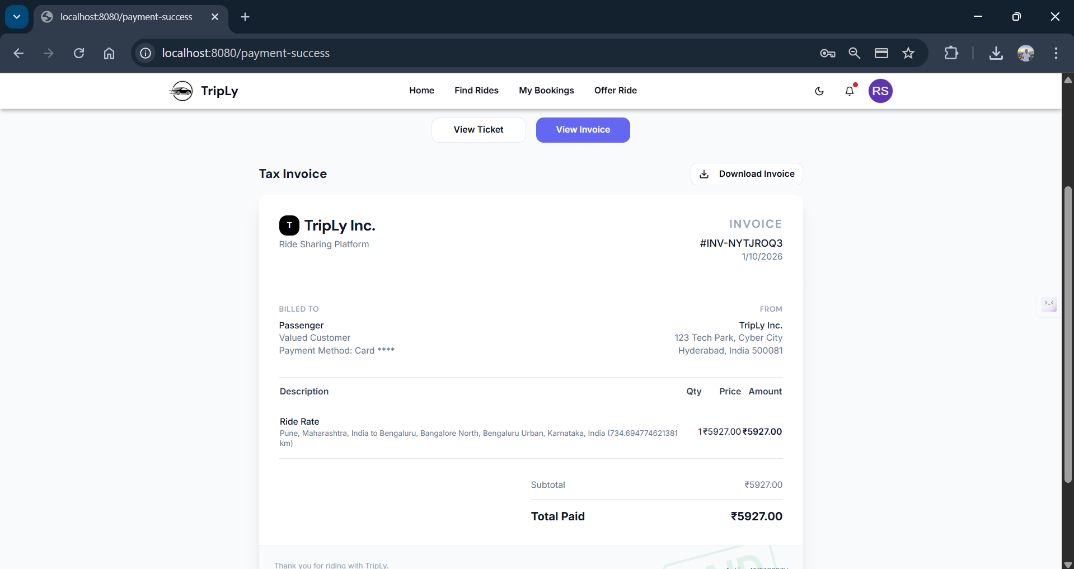

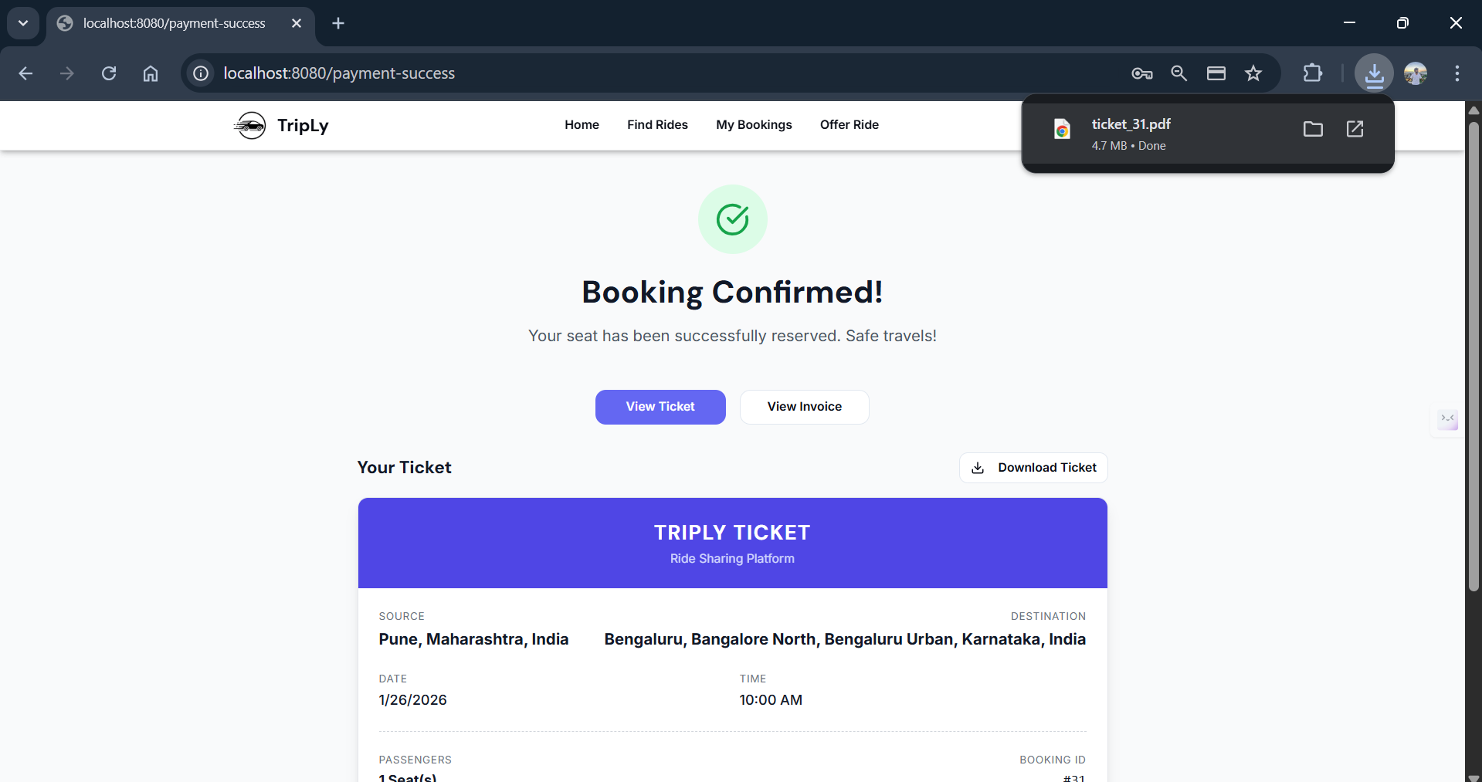3.23 : Payment/Booking Invoice

3.24 : Ticket Download

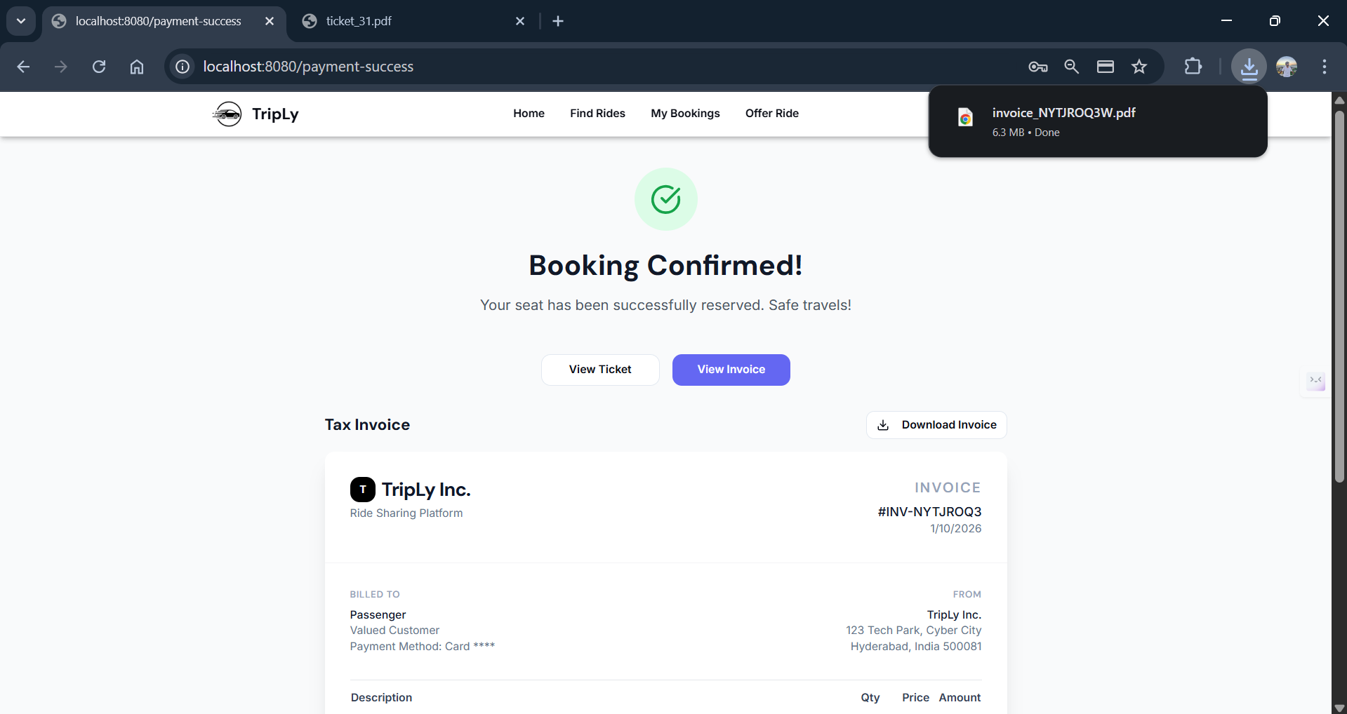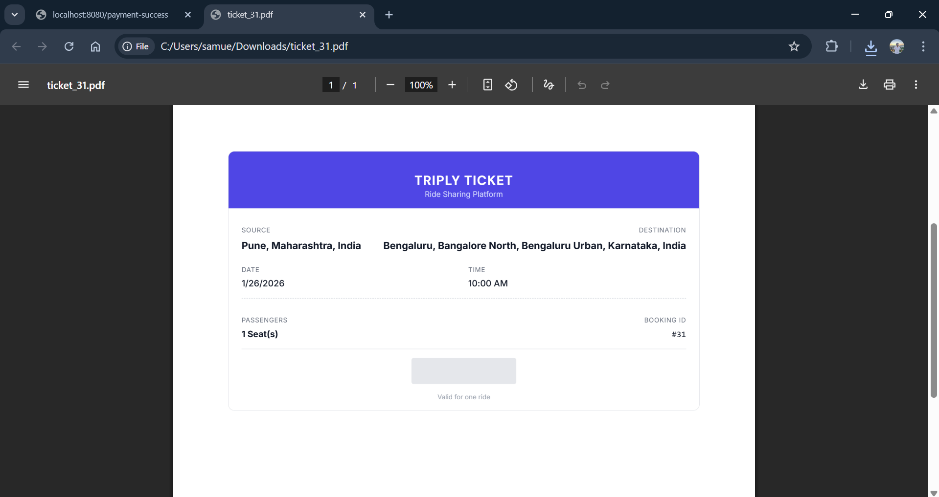

3.25 : Downloaded ticket in PDF format

3.26 : Invoice Download

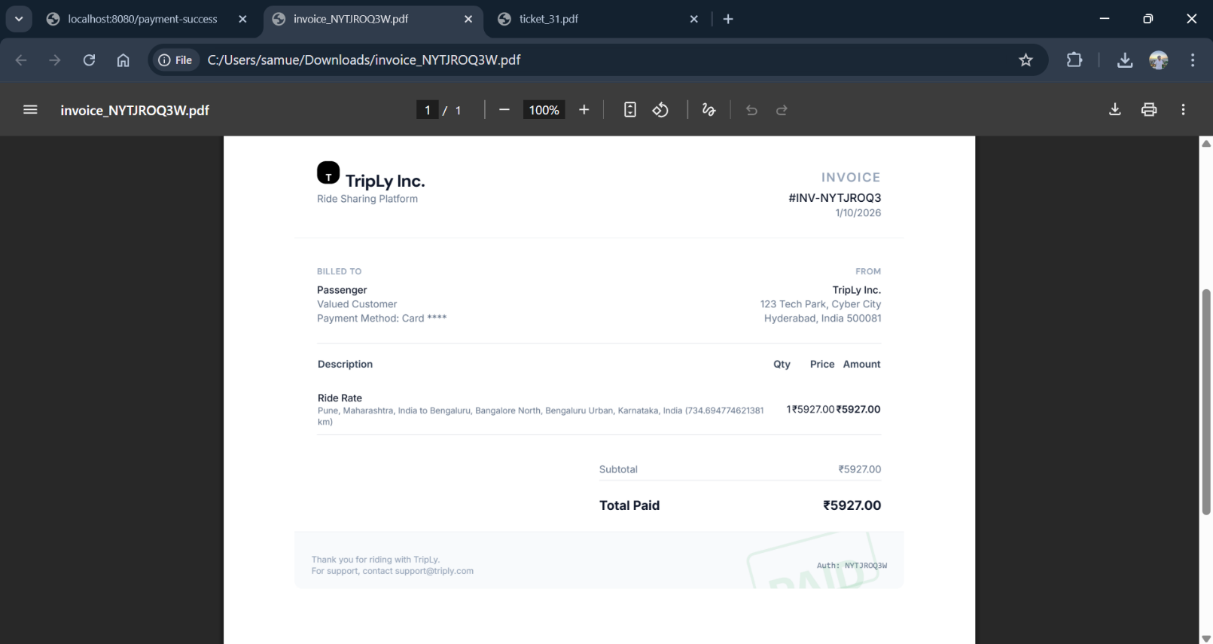

3.27 : Downloaded Invoice in PDF format

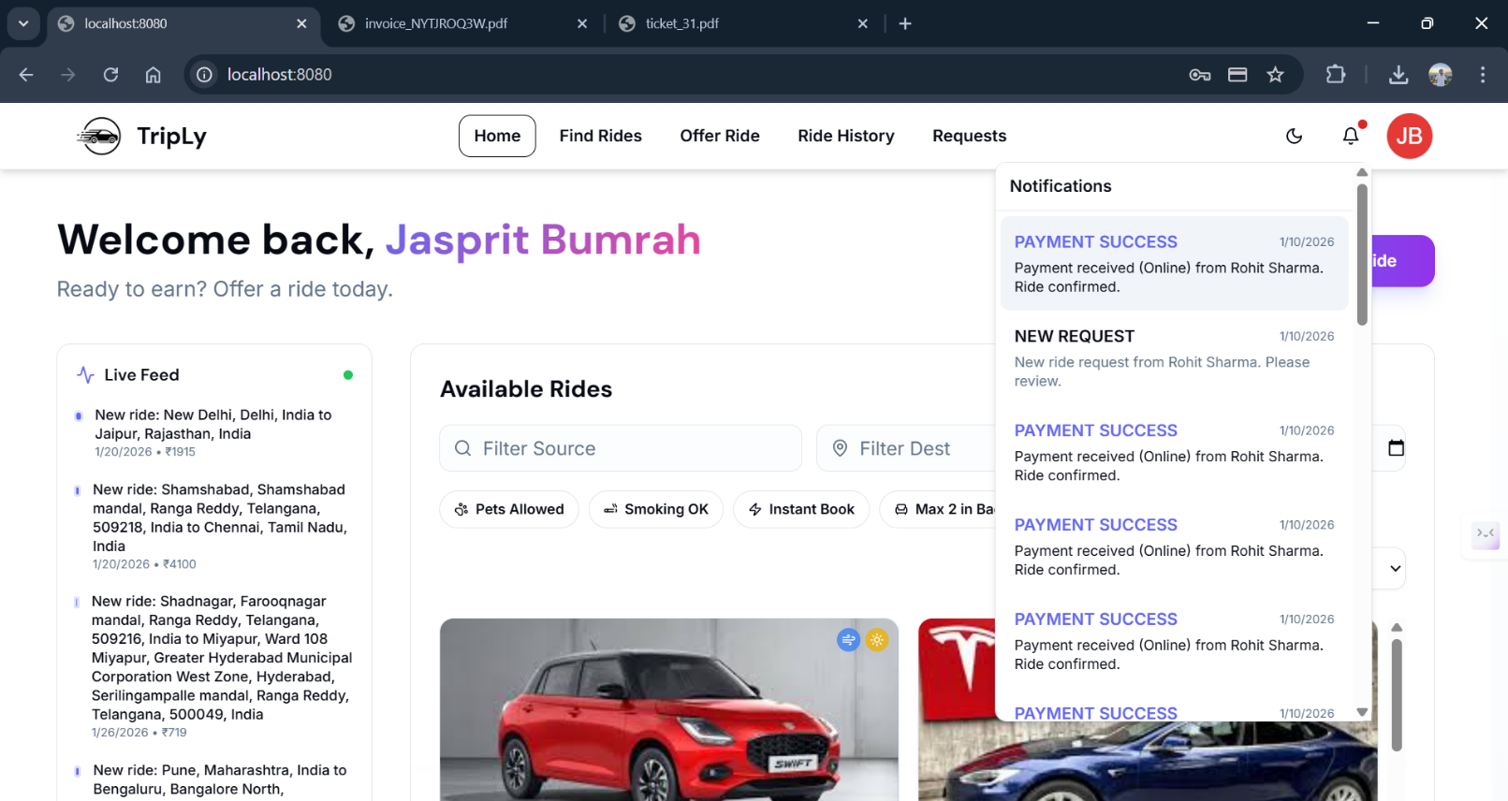

3.28 : Notification to driver that payment success

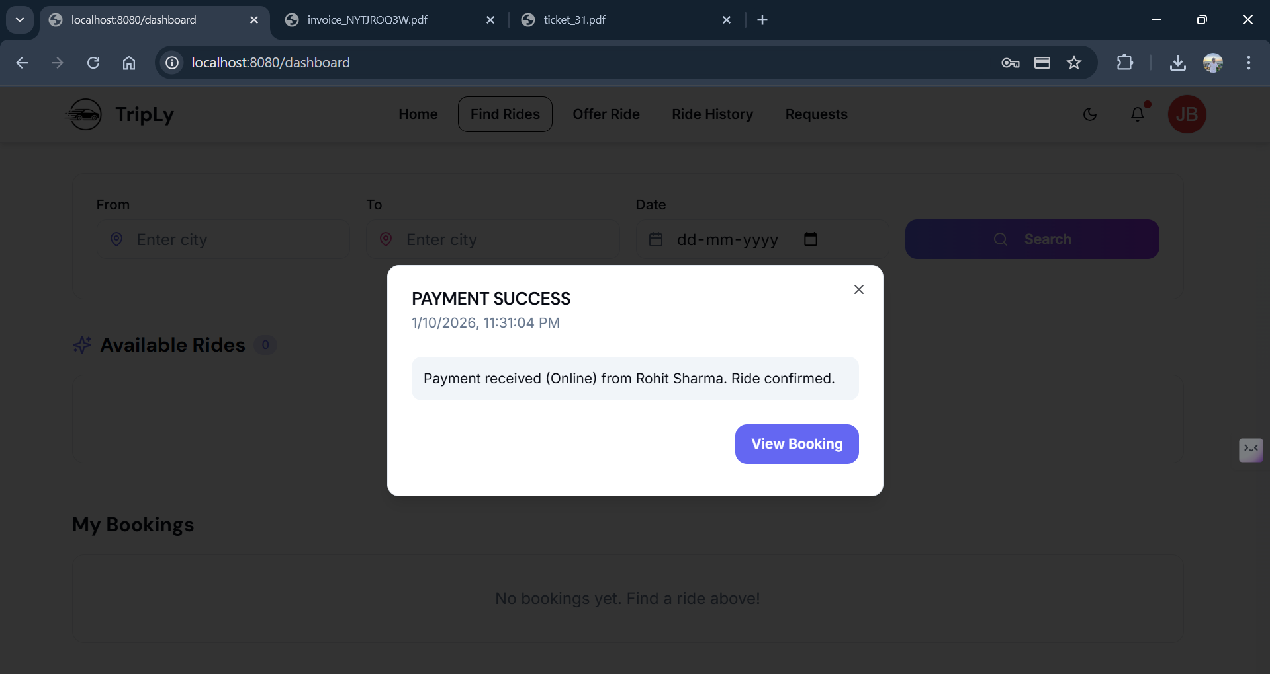

3.29 : Driver side Notification

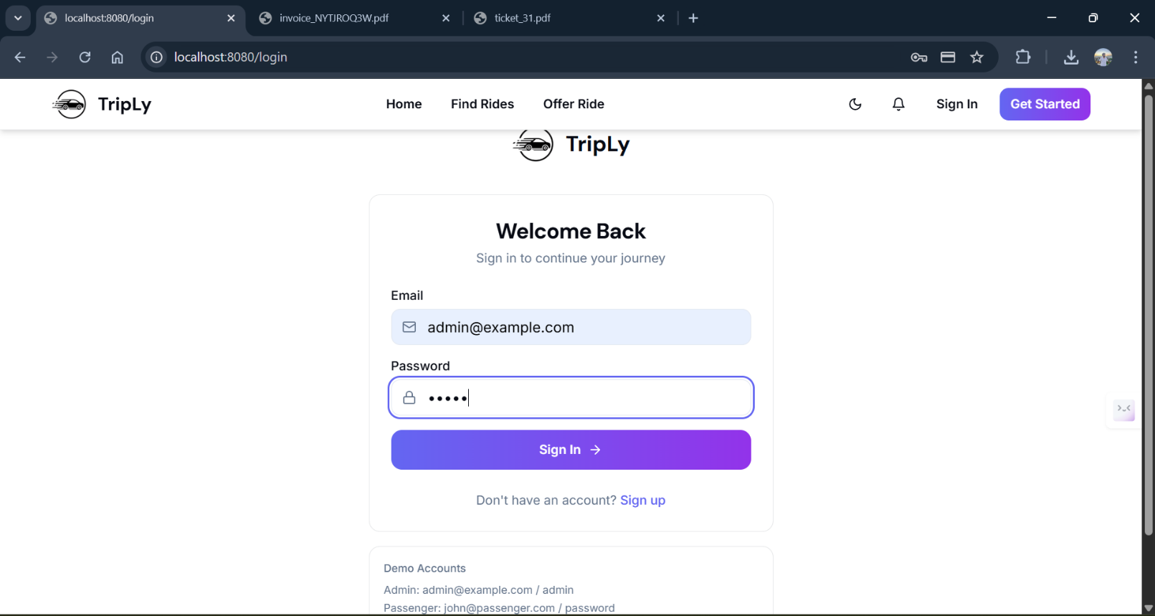

3.30 : Admin Login Credentials

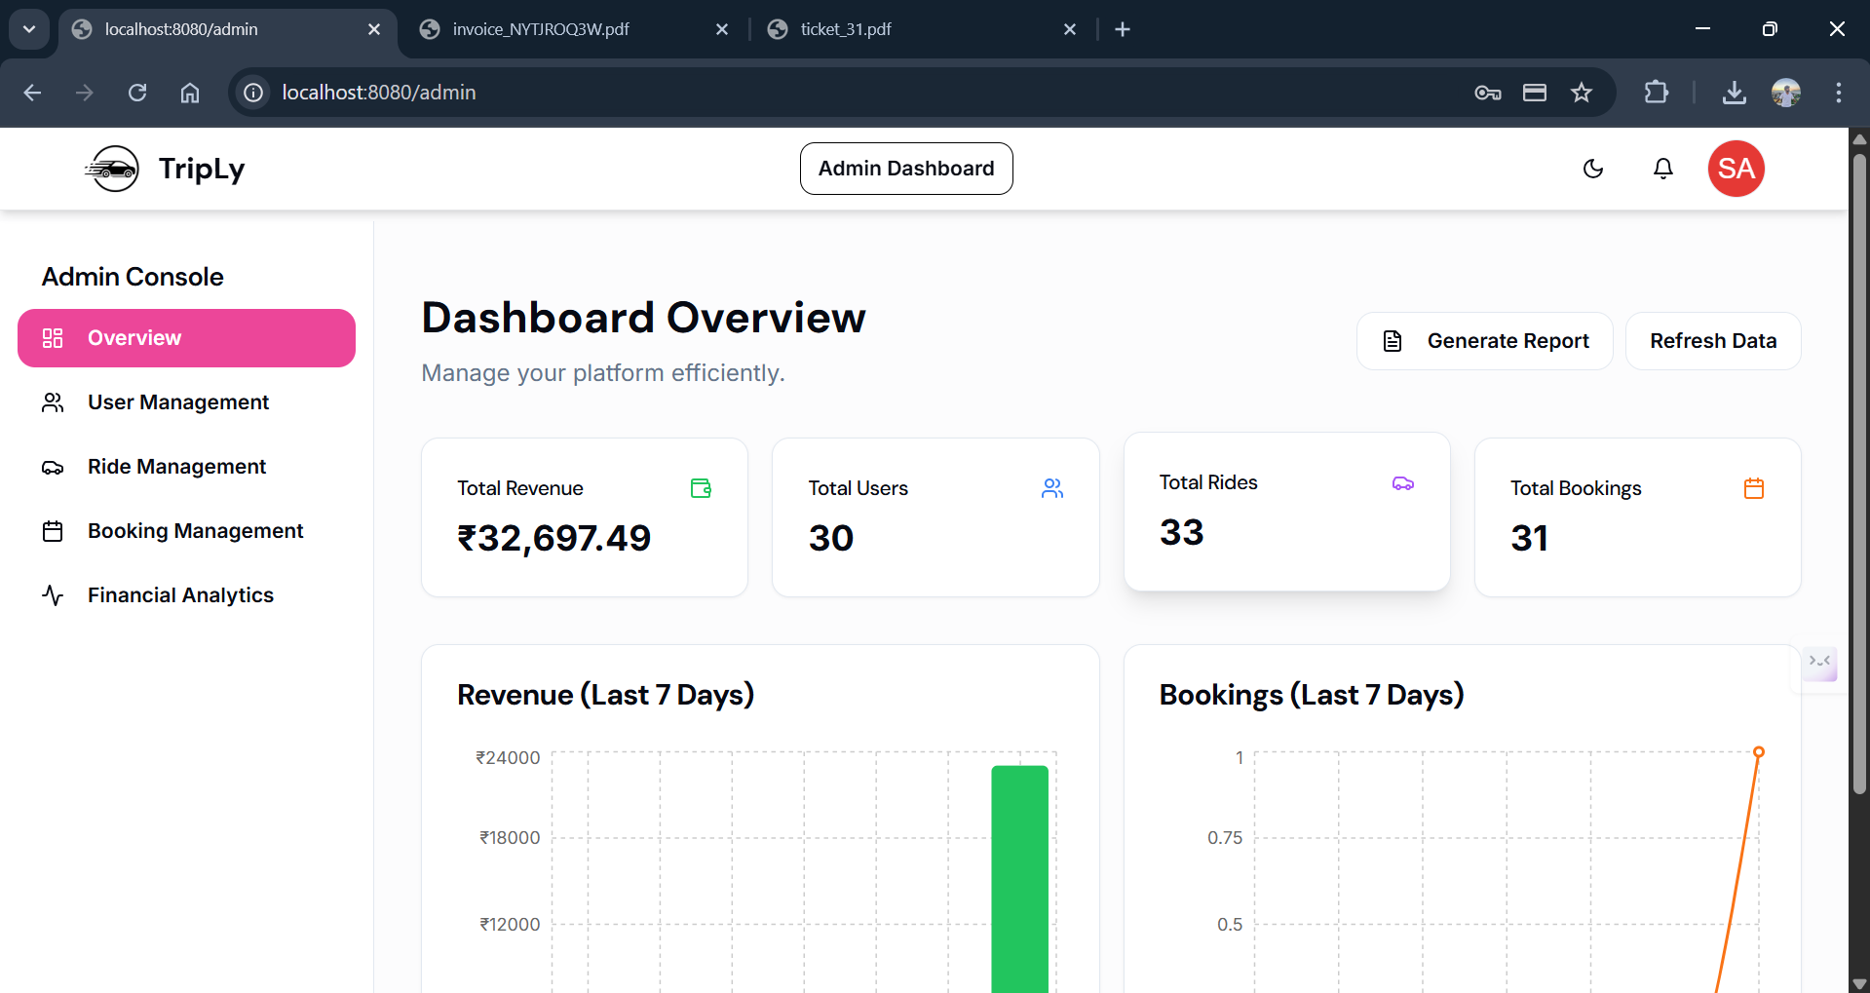

3.31 : Admin Dashboard

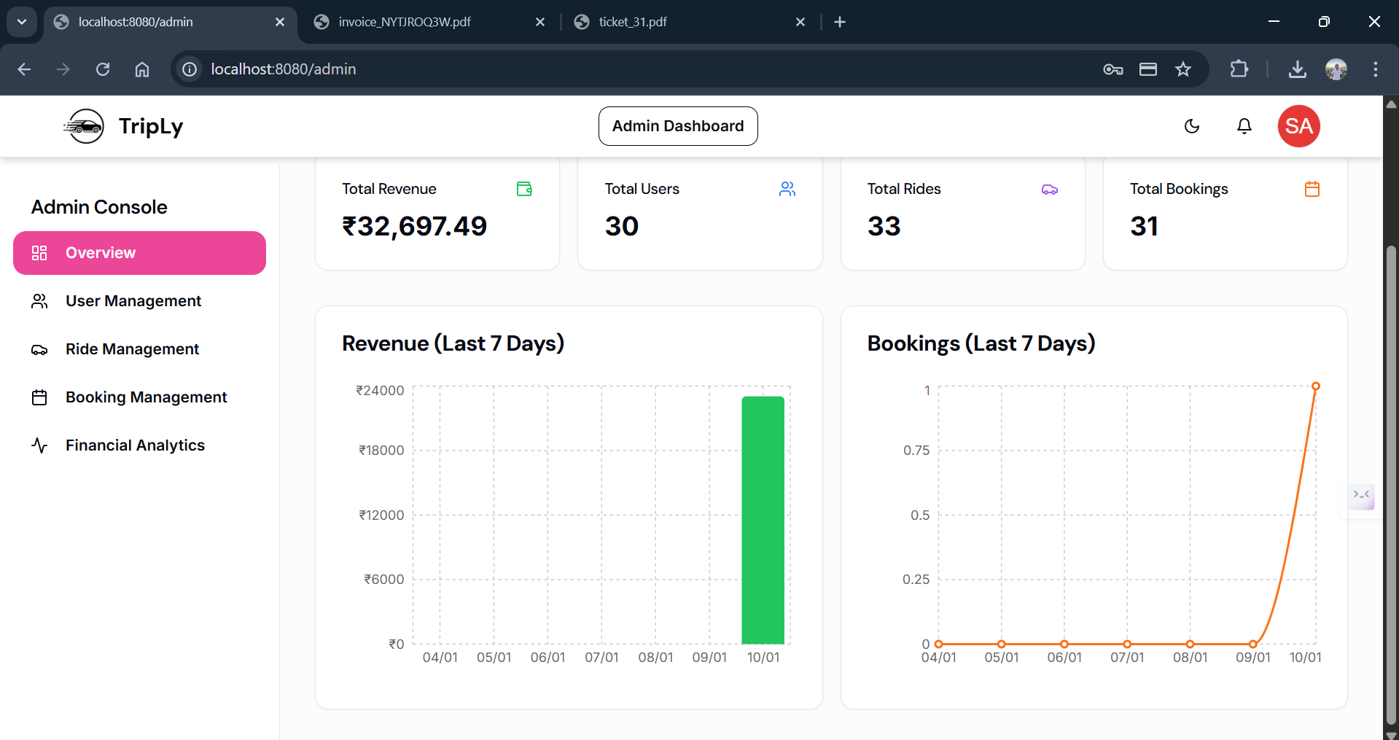

3.32 : Admin Dashboard

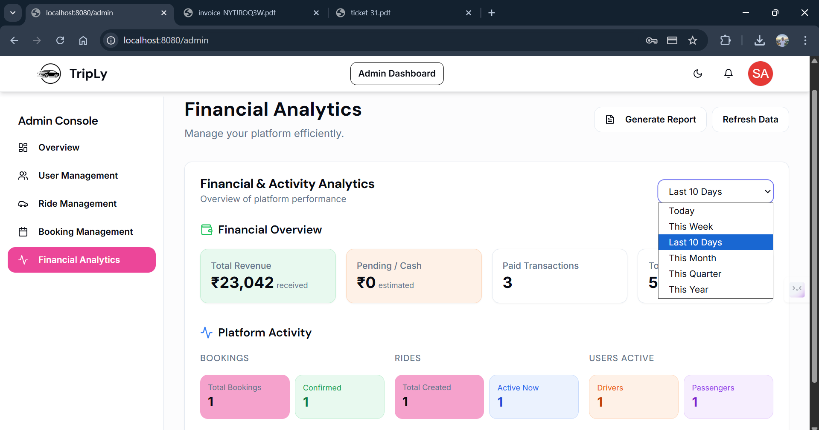

3.33 : Financial Analytics with range of days

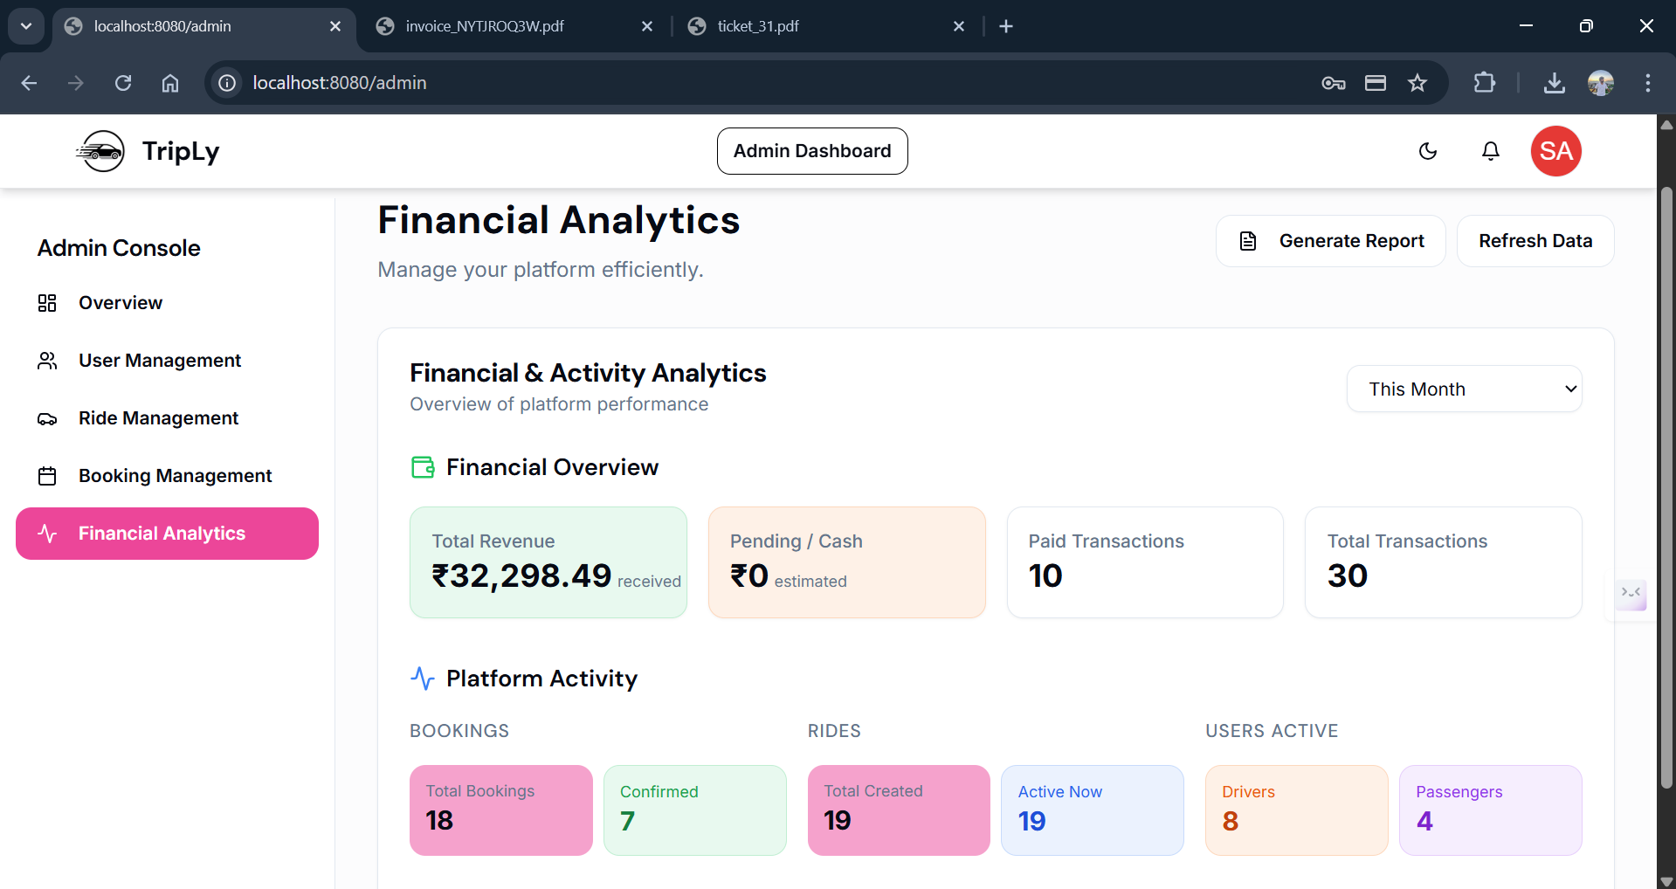

3.34 : Financial Analytics with range of days

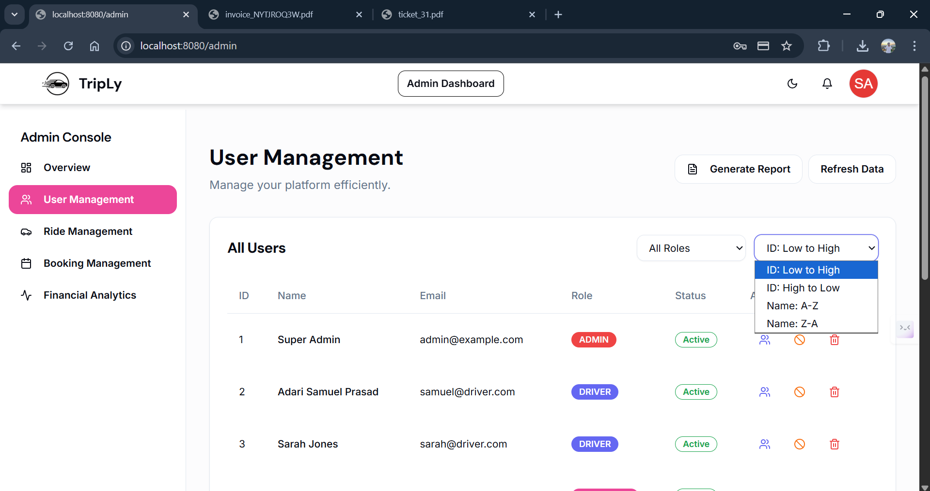

3.35 : User Management with sorting and Pagination

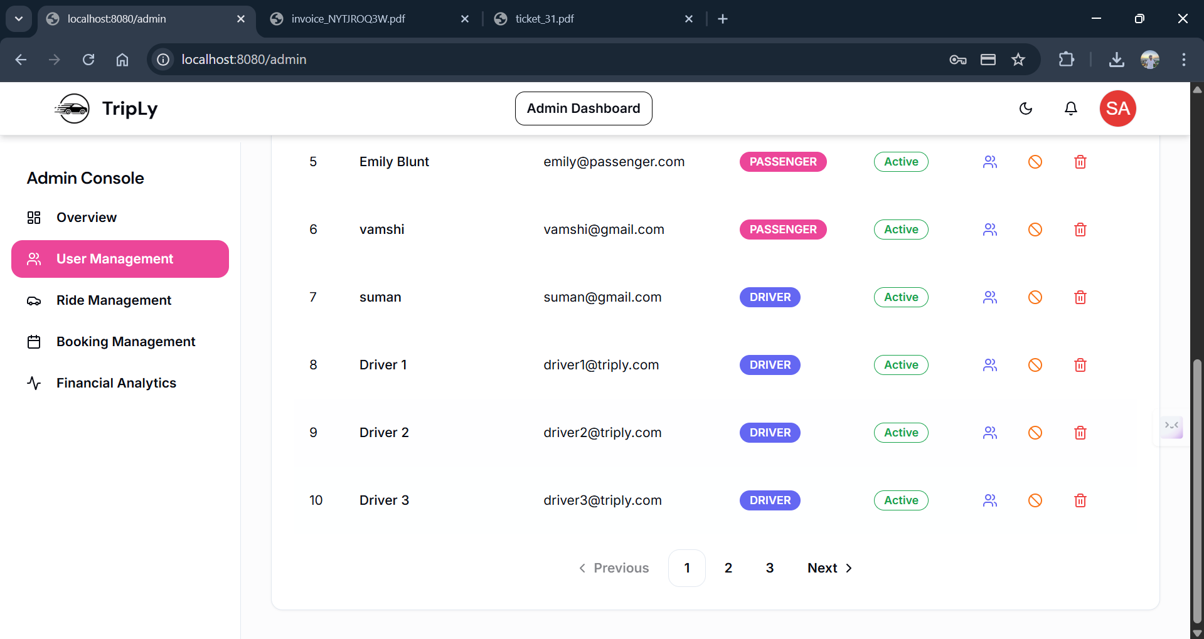

3.36 : User Management with sorting and Pagination

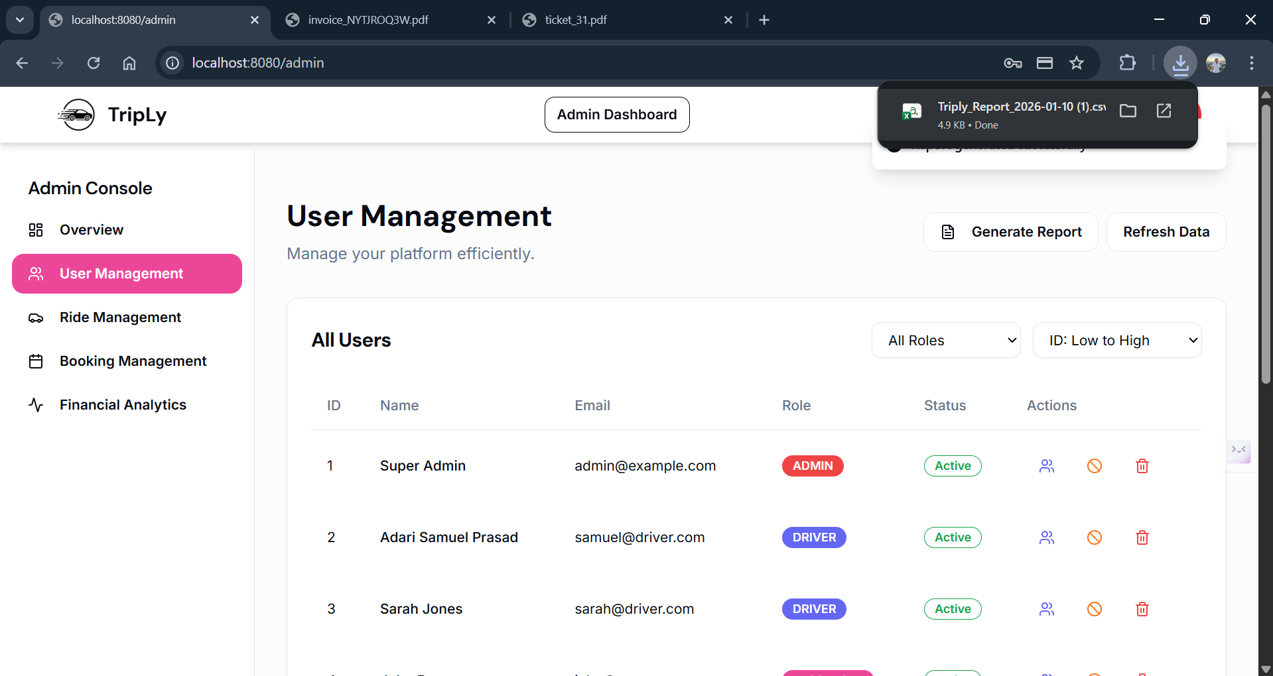

3.37 : Downloaded Overall Report

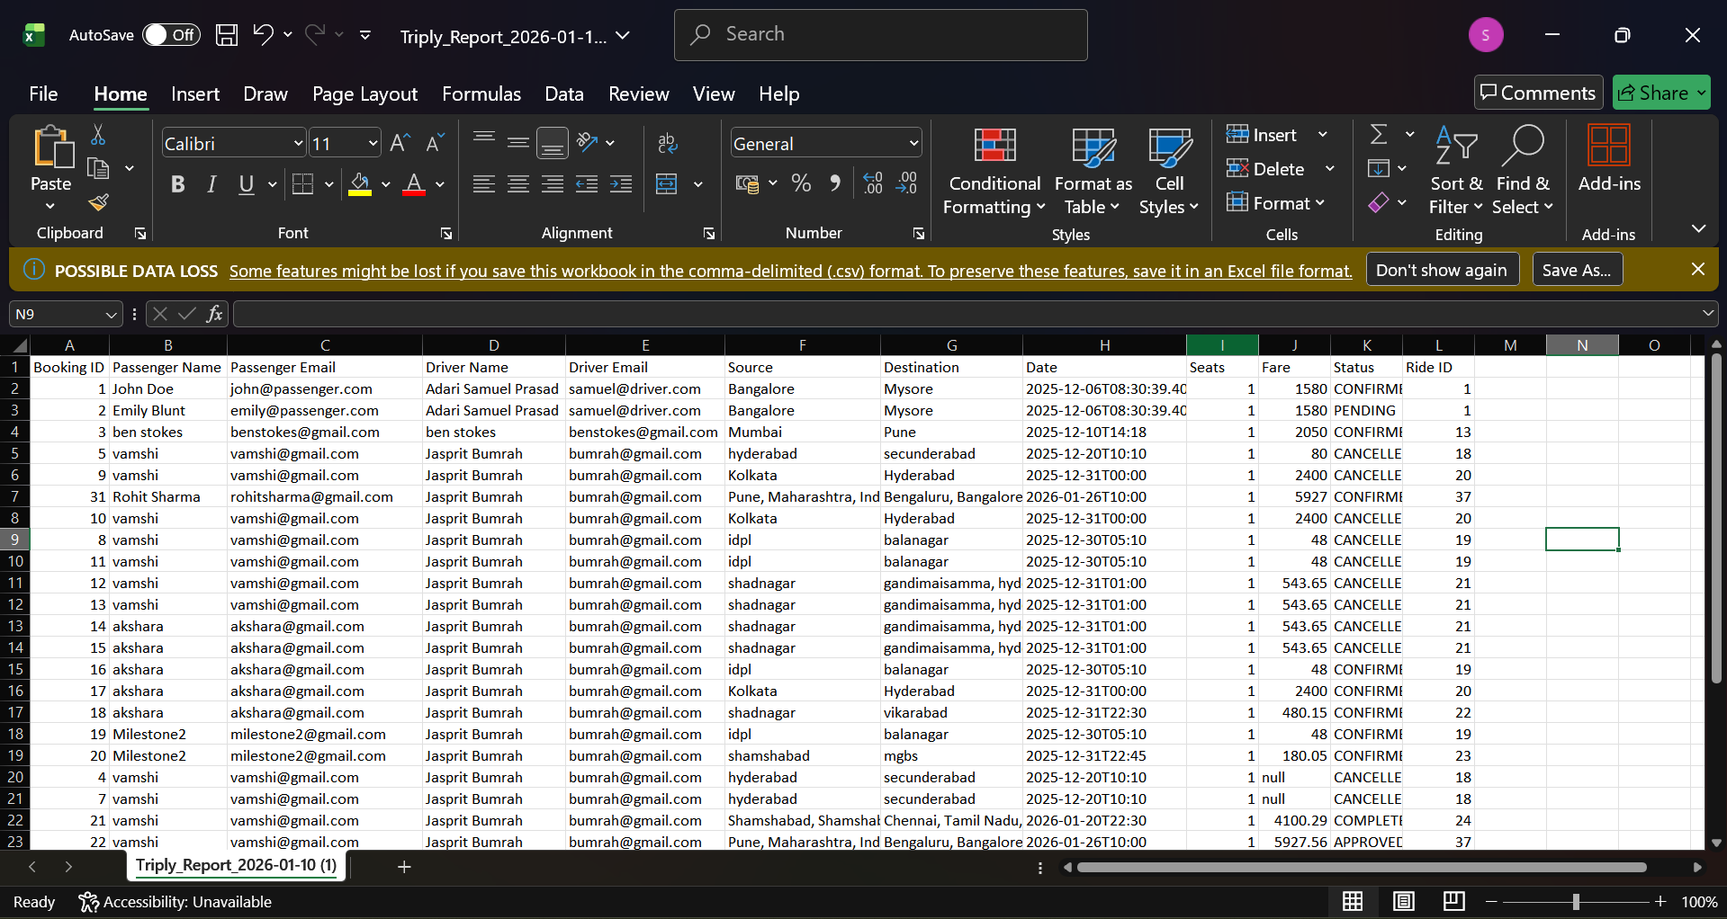

3.38 : Over all Report of TripLy